**Load Regulation Test**

In order to test the load regulation of the system we simply connect a parallel load with the same resistance to the output. Initially, circuit starts with full-load or half-load but since there is a switch which series with the additional load, we can control its existence in the circuit. in other words we can make “On” and “OFF” to the mosfet thus connecting and disconnecting the parallel resistance at the output.

1. **Half load to full load**

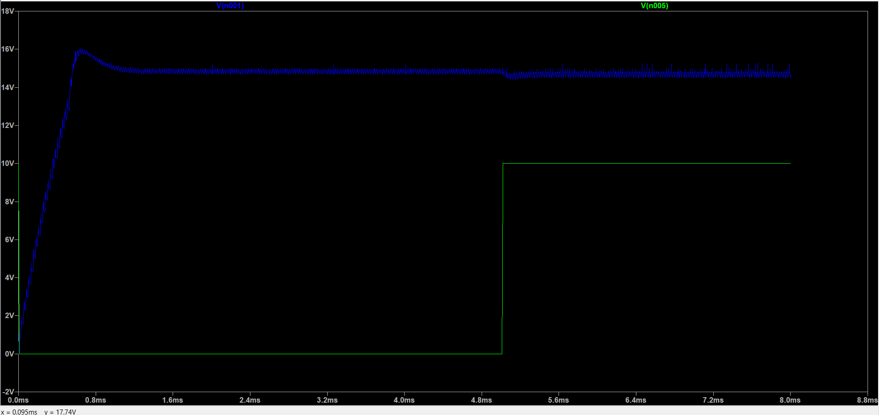

FigureXX: Half load to full load

1. **Full load to Half Load**

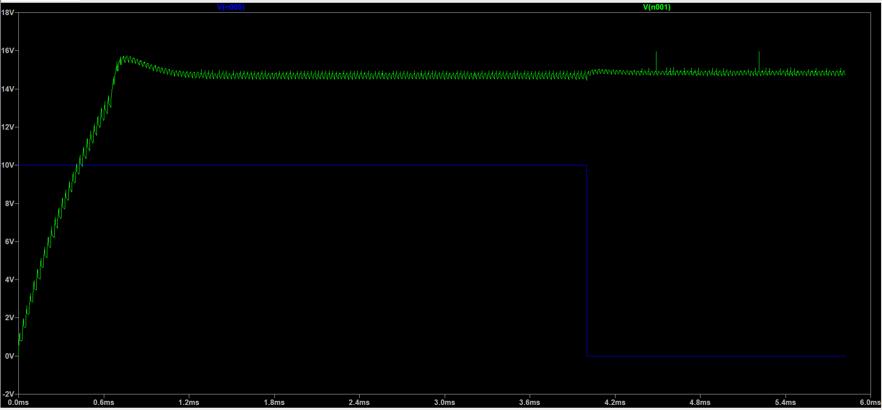

FigureXX:Full load to half load.

As we can see from the figures controller can react fastly and return the output voltage to its reference however returning may not be perfect since those controller are not perfect and are not linear in all the regions that the output value fallow.

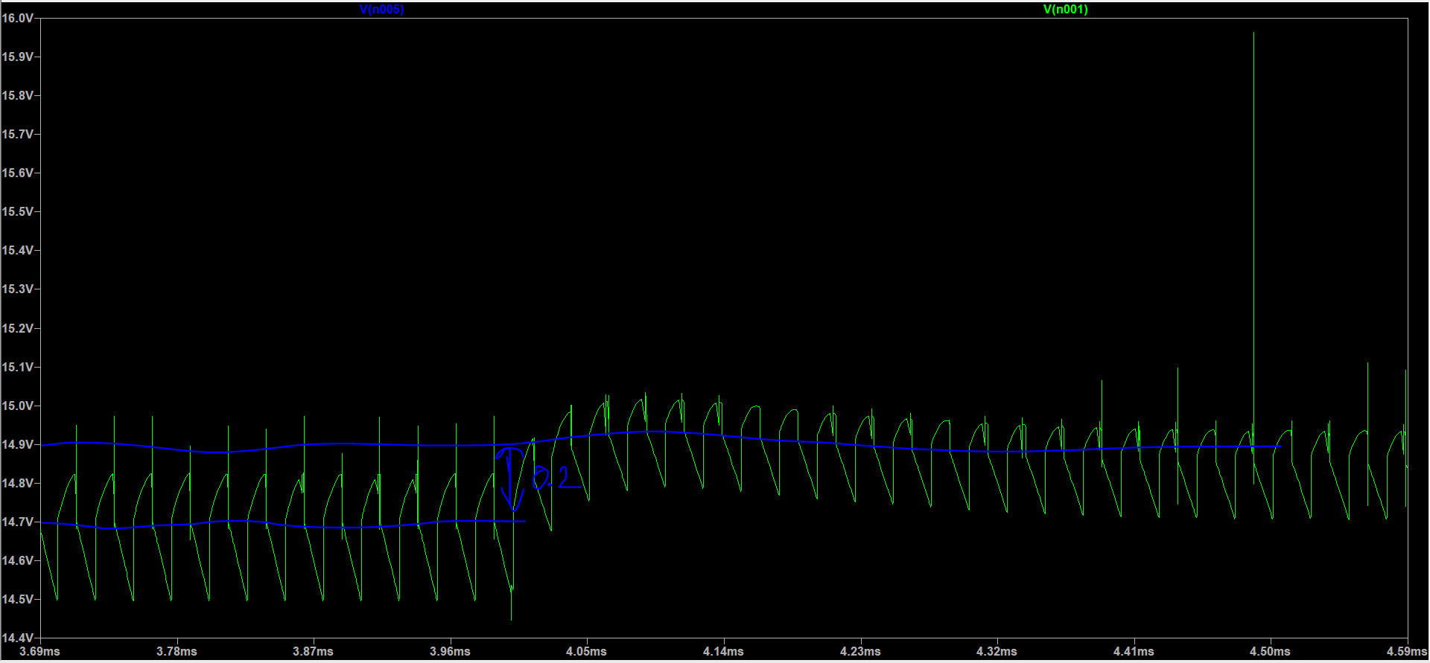

Figure XX measurement of the load regulation.

As can be seen from the figure difference between loads is 0.2 volt so,

0.2/15=%1.33 load regulation which is under %2